# Bansilal Ramnath Agarwal Charitable Trust’s

# Vishwakarma Institute of Technology, Pune-37

*(An autonomous Institute of Savitribai Phule Pune University)*

**Router Setup**

**Problem Statement: -**

Configuration of a router to create a small network

**Theory:**

1. Switch:

A switch is a device that connects multiple devices within a local area network (LAN). It uses MAC addresses to forward data only to the intended recipient device, ensuring efficient and secure data transfer. Unlike a hub, which broadcasts data to all connected devices, a switch intelligently directs data to the correct destination, reducing network congestion and improving overall performance.

Applications:

* Small Office Network: A small office with 20 employees, each with their own computer. Additionally, the office has network printers, a network-attached storage (NAS) device, and a VoIP phone system.
* Home Network with Smart Devices: A modern home with multiple smart devices such as smart TVs, smart thermostats, security cameras, gaming consoles, computers, tablets, and smartphones, all requiring a stable and high-speed network connection.

Specifications:

* Port count: 8 to 48 Ports
* Speed: Gigabit Ethernet (10/100/1000 Mbps)
* Layer: 2/3-layer switch

2. Router:

A router is a device that forwards data packets between computer networks. It directs traffic on the internet, determining the best path for data to travel from the source to the destination. Routers connect different networks together, such as connecting a home network to the internet, and they often provide additional functions like network address translation (NAT) and dynamic host configuration protocol (DHCP).

Applications:

* **Home Network:** Connecting multiple devices such as computers, smartphones, tablets, and smart devices to the internet and each other.
* **Enterprise Network:** Managing and directing data traffic between different subnets and ensuring efficient communication between departments and branches.

Specifications:

* **Port count:** Typically 4 to 8 LAN ports, 1 to 2 WAN ports
* **Speed:** Gigabit Ethernet (10/100/1000 Mbps), with some models supporting 10 Gbps
* **Wireless Support:** Wi-Fi 5 (802.11ac) or Wi-Fi 6 (802.11ax)
* **Security Features:** Firewall, VPN support, WPA3 encryption

3. Gateway:

A gateway is a network node that serves as an access point to another network. In enterprise environments, a gateway often acts as a proxy server and a firewall. It can translate data between different protocols and formats, allowing communication between different network architectures or environments.

Applications:

* **Enterprise Network:** Connecting a corporate LAN to the internet, often incorporating security features like firewalls and intrusion detection systems.
* **IoT Network:** Connecting various Internet of Things (IoT) devices to the main network and enabling communication between different protocols used by IoT devices.

Specifications:

* **Port count:** Typically 4 to 8 LAN ports, 1 to 2 WAN ports
* **Speed:** Gigabit Ethernet (10/100/1000 Mbps)
* **Functions:** Protocol translation, firewall, VPN, DHCP server
* **Security Features:** Advanced firewall, intrusion detection/prevention system (IDS/IPS), antivirus

4. Hub:

A hub is a basic networking device that connects multiple Ethernet devices in a local area network (LAN). Unlike a switch, a hub broadcasts incoming data packets to all connected devices, regardless of the intended recipient. This can lead to network inefficiencies and collisions, making hubs less commonly used in modern networks compared to switches.

Applications:

* **Small Network:** Simple, small-scale networks where advanced features and high efficiency are not required.
* **Legacy Systems:** Older networks where cost is a primary concern and only basic connectivity is needed.

Specifications:

* **Port count:** 4 to 24 Ports
* **Speed:** Fast Ethernet (10/100 Mbps), with some older models supporting only 10 Mbps
* **Type:** Passive or Active (with some models providing amplification of the signal)

**Use cases**

1. Switch

Use Case: Office Networking

Description:

Connects multiple devices within a LAN, ensuring efficient data communication.

Example:

An office connects computers, printers, and servers using a switch, allowing seamless data transfer and communication between these devices.

1. Router

Use Case: Home Internet Access

Description:

Connects different networks and routes data packets between them, typically linking a local network to the internet.

Example:

A home router connects to the ISP's modem, creating a local network for devices like smartphones, laptops, and smart home devices to access the internet.

1. Gateway

Use Case: Enterprise Network Security

Description:

Acts as a bridge between different networks, managing protocol translation and ensuring secure data transfer.

Example:

An enterprise uses a gateway to connect its internal secure network with the internet, providing data translation and firewall protection.

1. Hub

Use Case: Small Network Setup

Description:

A basic device that connects multiple Ethernet devices, broadcasting data to all connected devices.

Example:

In a small office, a hub connects a few computers, allowing them to communicate by broadcasting data to each connected device, though less efficiently than a switch.

**Networking Commands**

### ping

### **Description**: Tests connectivity between two networked devices by sending ICMP Echo Request packets and waiting for Echo Reply packets.

### **Use Cases**:

* Checking if a specific host is reachable.
* Measuring round-trip time (latency).

**Syntax**:

ping [options] destination

**Example**:

ping google.com

### traceroute

### **Description**: Traces the route packets take to a network host, showing each hop along the way.

### **Use Cases**:

* Diagnosing routing issues.
* Determining the path taken to reach a destination.

**Syntax**:

traceroute [options] destination

**Example**:

traceroute google.com

### ifconfig

### **Description**: Configures or displays network interface parameters for Unix/Linux systems.

### **Use Cases**:

* Viewing or changing IP addresses.
* Checking network interface status.

**Syntax**:

ifconfig [interface] [options]

**Example**:

ifconfig eth0

### ip

### **Description**: Shows/manipulates routing, devices, policy routing, and tunnels.

### **Use Cases**:

* Managing IP addresses.
* Configuring network interfaces.

**Syntax**:

ip [options] object { COMMAND | help }

**Example**:

ip addr show

### netstat

### **Description**: Displays network connections, routing tables, interface statistics, masquerade connections, and multicast memberships.

### **Use Cases**:

* Monitoring network connections.
* Troubleshooting network issues.

**Syntax**:

netstat [options]

**Example**:

netstat -an

### nslookup

### **Description**: Queries Domain Name System (DNS) to obtain domain name or IP address mapping.

### **Use Cases**:

* Checking DNS records.
* Troubleshooting DNS issues.

**Syntax**:

nslookup [options] [name | -] [server]

**Example**:

nslookup google.com

### dig

### **Description**: Queries DNS servers for information about host addresses, mail exchanges, nameservers, and related information.

### **Use Cases**:

* Detailed DNS queries.
* Verifying DNS configurations.

**Syntax**:

dig [options] [name] [type]

**Example**:

dig google.com

### arp

### **Description**: Displays and modifies the IP-to-Physical address translation tables used by the ARP protocol.

### **Use Cases**:

* Viewing or managing ARP cache.
* Troubleshooting network issues related to ARP.

**Syntax**:

arp [options] [hostname]

**Example**:

arp -a

### route

### **Description**: Displays or modifies the IP routing table.

### **Use Cases**:

* Managing static routes.
* Viewing the current routing table.

**Syntax**:

route [options] [command] [target]

**Example**:

route -n

### curl

### **Description**: Transfers data to or from a server, using supported protocols (HTTP, FTP, etc.).

### **Use Cases**:

* Testing REST APIs.
* Downloading or uploading files.

**Syntax**:

curl [options] [URL...]

**Example**:

curl https://www.google.com

Home Gateway Unit:

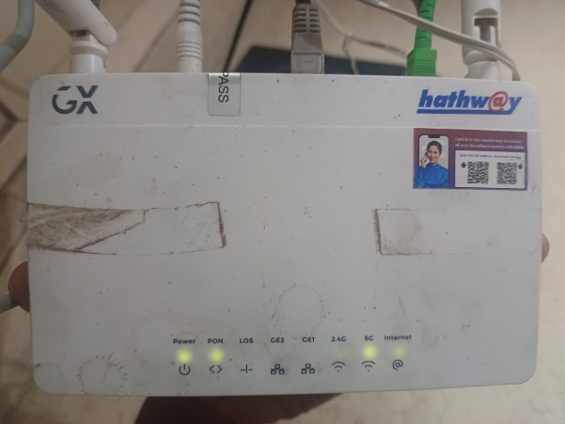 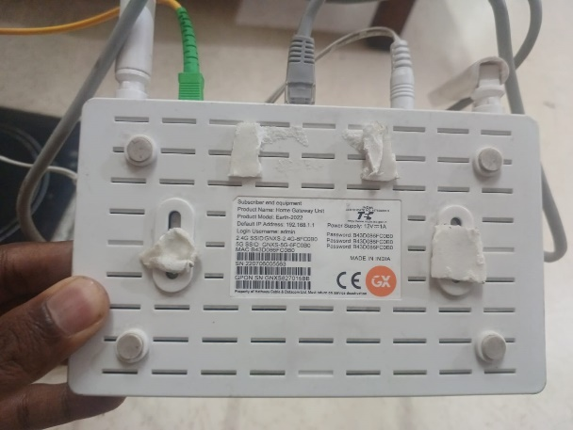

Device information:

* Product Name: Home Gateway Unit
* Product Model: EG-2022
* Default IP Address: 192.168.1.1
* Login Username: admin
* 2.4G SSID: GNXS-2.4G-6FC0B0
* 5G SSID: GNXS-5G-6FC0B0
* MAC Address: B4:3D:08:6F:C0
* Power Supply: 12V, 1A
* Manufacturer: GX
* Country of Manufacture: India

Features:

* Dual-Band Wi-Fi: Provides both 2.4 GHz and 5 GHz wireless networks for better performance and range.
* Ethernet Ports: Multiple LAN ports for wired connections to devices such as computers, printers, and other network hardware.
* Management Interface: Web-based management interface accessible via the default IP address.
* Security Features: Basic security features including password-protected access to the management interface and Wi-Fi networks.

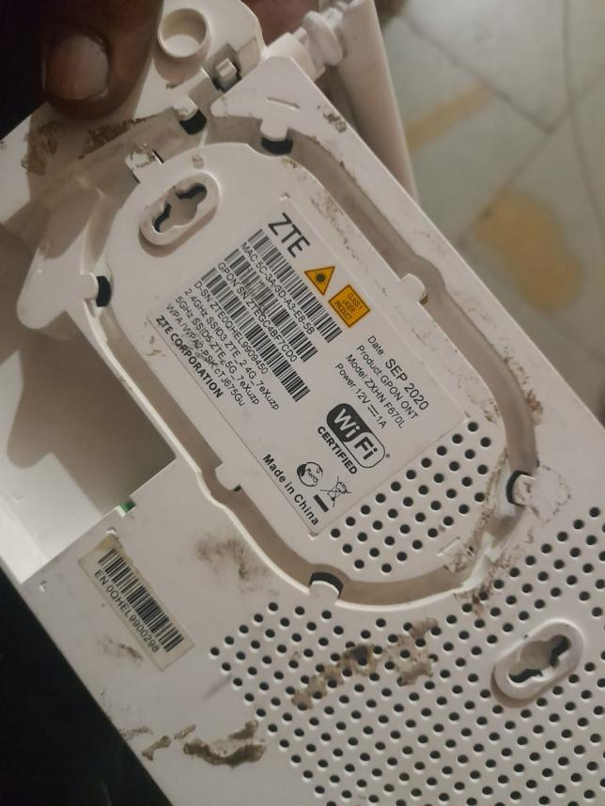

**Device Information:**

* Name: ZTE CORPORATION
* Product: GPON ONT
* Model: ZXHN F670L
* Power: 12V == 1A
* Date: SEP 2020
* 2.4G SSID3ZTE_2.4G_7eXuzp
* 5G SSID5 ZTE_5G_7eXuzp
* MAC Address: 5C-3A-3D-A3-E8-5B
* Country of Manufacture: China

**How to login to ZTE Router?**

1. Open a browser and type **192.168.1.1** or **192.168.0.1** in the address bar.
2. Enter **admin** for Username and Password and click Login. If admin doesn’t work, try **Web@0063** for password.  
   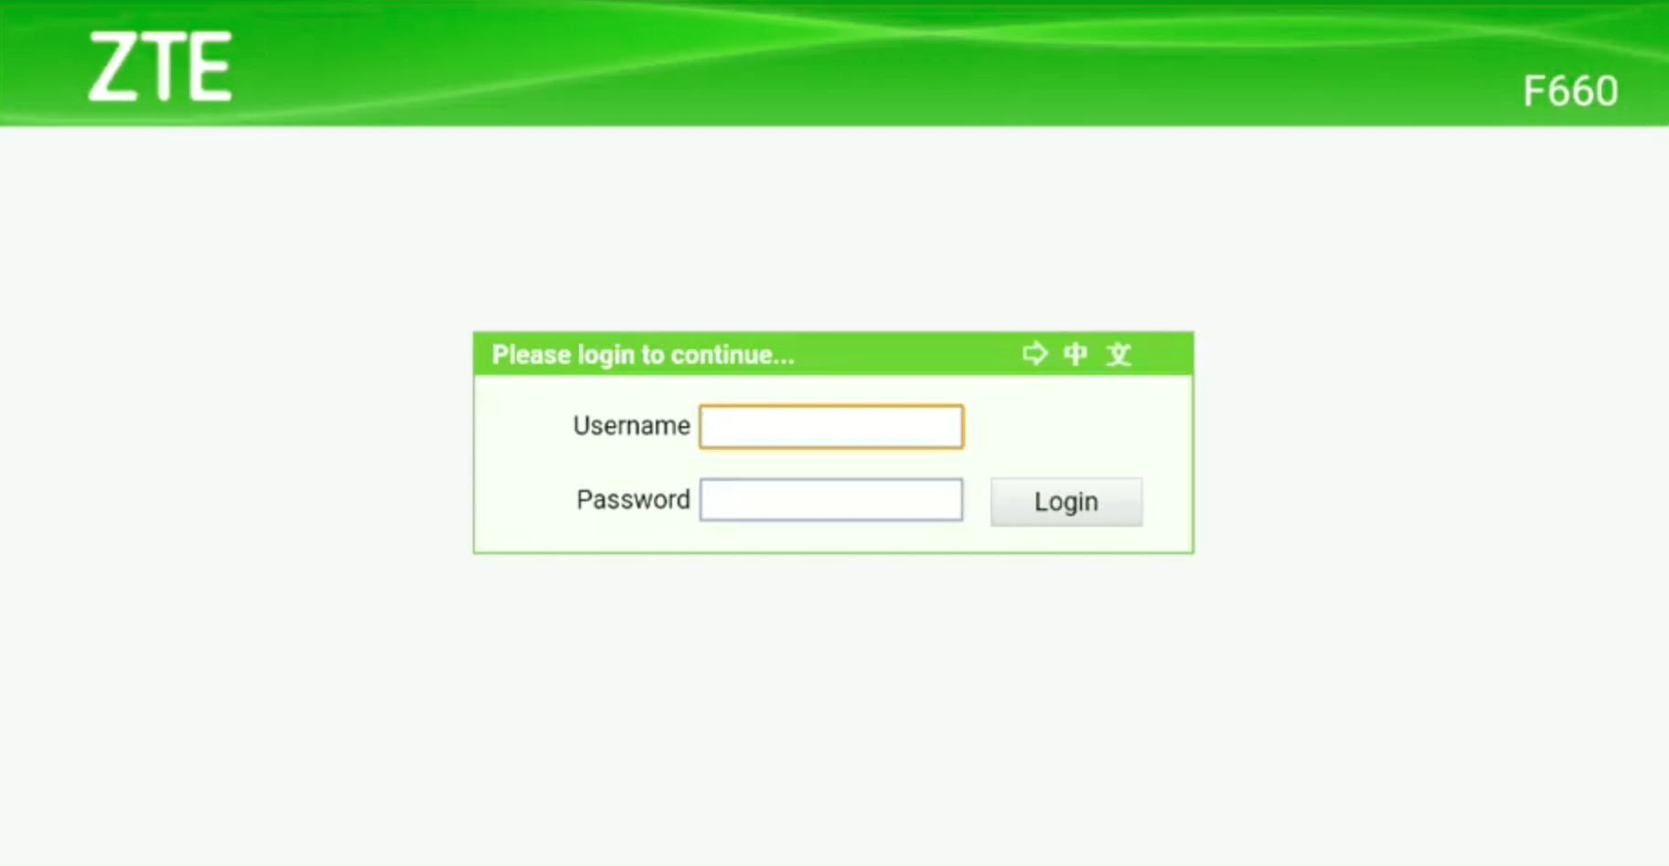
3. You will be now logged into your ZTE Router interface.

The process is compatible with ZTE F609, F660, F680, F668, and other ZTE router models.

**How to Change WiFi Network Name (SSID) on ZTE Routers?**

1. Open a browser and type **192.168.1.1** or **192.168.0.1** in the address bar.
2. Login with the Username and Password you have set for your router.
3. Click **Network** from the left menu and then select **WLAN.**
4. Under the **WLAN** section, select **SSID Settings.  
   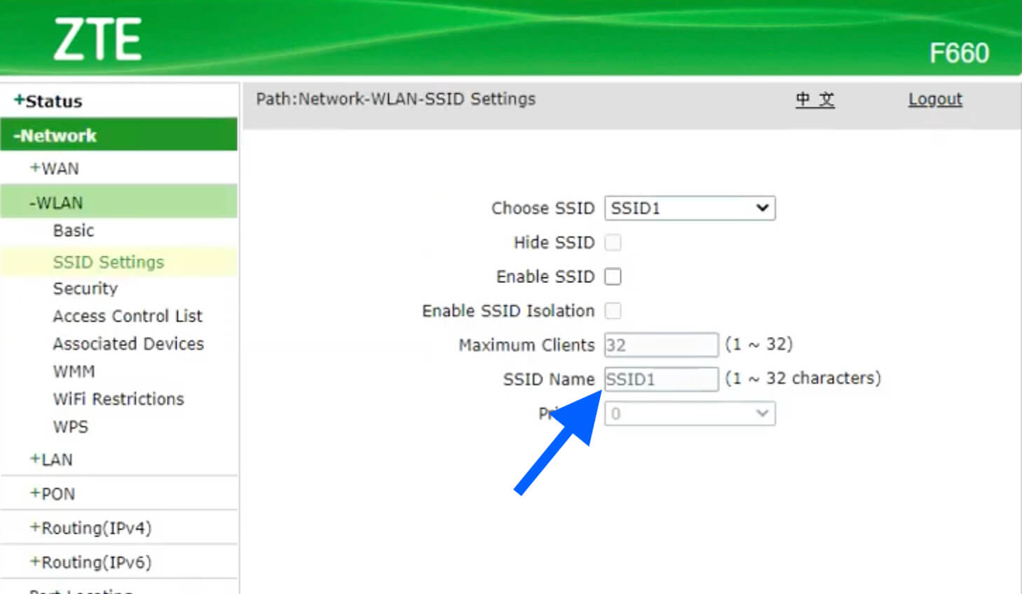**
5. Choose SSID1 and enter the new WiFi name in the **SSID Name** field.
6. Click on **Submit** button to save the changes.

**How to Change WiFi Password on ZTE Routers?**

1. Open a browser and type **192.168.1.1** or **192.168.0.1** in the address bar.
2. Login with the Username and Password you have set for your router.
3. Click on **Network** from the left menu and then select **WLAN.**
4. Under the **WLAN** section, select **Security.  
   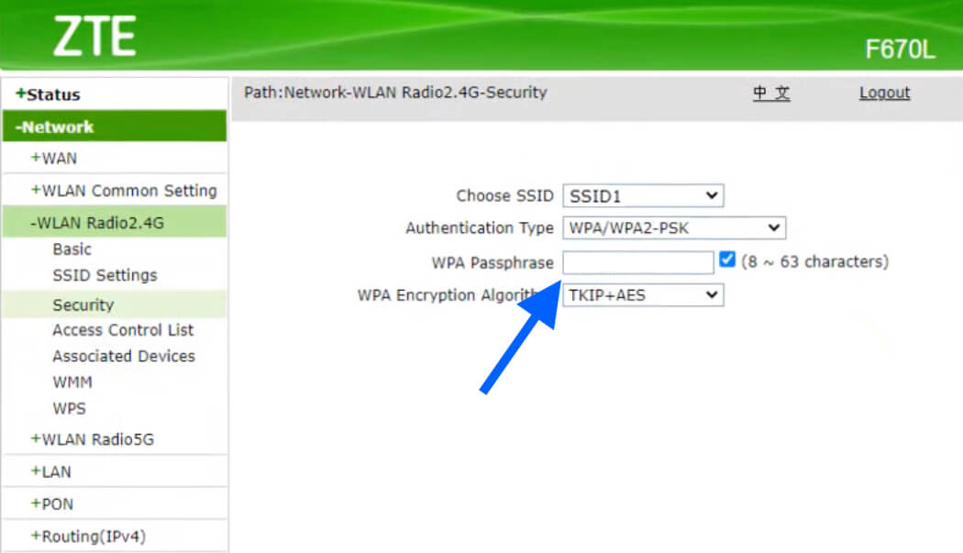**
5. Choose SSID1 and select Authentication Type as **WPA/WPA2-PSK**.
6. Enter the new WiFi password in the **WPA Passphrase** field.
7. Click on the **Submit** button to save the changes.

[**All Blog Posts**](https://19216811.uno/blog/)

**FILE SHARING USING WIFI**

If you want to share files between Windows 10 laptop and Windows 11 PC, you can do it through **Windows Shared Directory**. But it requires that **both devices are on the same private network**.

1. **Turn on network discovery**

Go to **Network** in File Explorer, and see an error message ("**Network discovery is turned off….**"), you'll need to turn on network discovery to see devices on the network that are sharing files. To turn it on, select the **Network discovery is turned off** banner, then select **Turn on network discovery and file sharing**.  
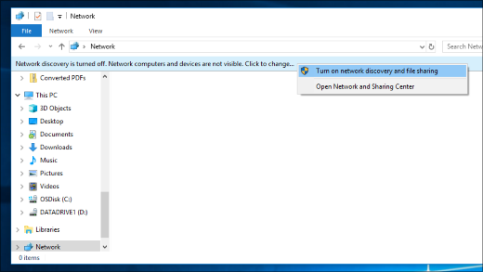

1. It should be noted that you need to **put both devices on the same network and set the network as a Private Network**, so that other devices in the same network are trustworthy and can be connected to both devices.
   * **Private network**. Use this for networks you trust, such as a network at home or work. When a network is set to private, your PC is discoverable to other devices on the network, and you can use your PC for file and printer sharing.
   * **Public network**. Use this for networks you connect to when you’re out and about, such as a Wi-Fi network at a coffee shop. Your PC will be hidden from other devices on the network, and you can’t use your PC for file and printer sharing.

**To change a Wi-Fi network to private**

* + On the right side of the taskbar, select the **Wi-Fi network**  icon.
  + Under the name of the Wi-Fi network that you’re connected to, select **Properties**.
  + Under **Network profile**, select **Private**.

1. Share a file or folder in **File Explorer**:
   * Right-click or press a file, select **Give access to**> **Specific people**.  
     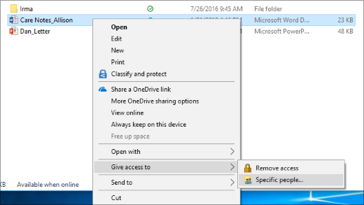
   * Select a file, select the **Share**tab at the top of File Explorer, and then in the **Share with**section select **Specific people**.  
     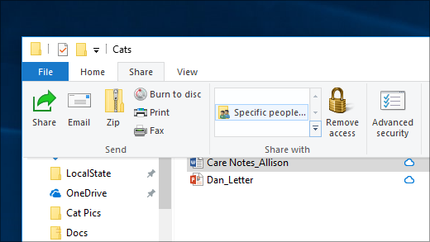
   * Select a user on the network to share the file with, or select **Everyone**to give all network users access to the file.
   * If you select multiple files at once, you can share them all in the same way. It works for folders, too—share a folder, and all files in it will be shared.

**Configuration**

Step 1: Connect both pc to router   
Step 2: Allow Nearby Sharing: public folders sharing

Step 3: run this on windows run - ncpa.cpl

Step 4: Open ethernet setting by clicking right click ->opening properties and enabling IPv4.

# How to configure wifi

Step 5: Connect the particular wifi

Step 6: open its admin website. http://192.168.2.1

Step 7: Login using Id & password

Id = admin

Password= 1234

Step 8: Go to setup page -> to Internet setup

Step 9: Select Static IP.

IP: 172.25.0.3.1

Sub 255.255.255.0

Default gateway 172.25.0.254

DNS Server 172.16.0.250

Alt DNS Server 8.8.8.8

Step 11: Setup Local network -> Lan interface setup

Step 12: Enter the router ip

Step 13: Apply changes.

Step 14 : <http://172.16.0.250:8090>

Step 15: Login with college id.

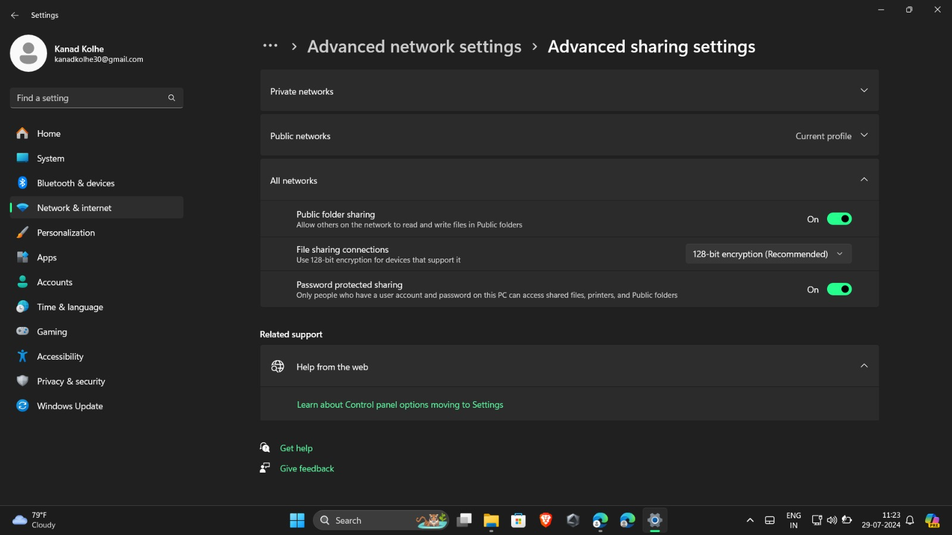

**ADVANCED NETWORK SETTINGS**

**Network notification**

When this feature is turned on, your phone will notify you when an un-protected Wi-Fi network is available in the area. It will then give you the option to connect to the network.

Un-protected Wi-Fi networks require no password or other secret credentials to access. Unfortunately, this is also a security risk.

Connecting to any Wi-Fi network gives the owner of that network the potential to monitor your activity online. For security reasons it is a good idea to connect only to Wi-Fi networks operated by people you trust.

**Blocked open networks**

A feature only found on some devices, this allows you to maintain a list of open networks that you do not want to be notified about, and do not want to connect to. This feature probably does not make sense if you do not use the above Network notification option.

As stated in the previous section, connecting to Wi-Fi networks owned by people you do not trust is a security risk.

**MAC address**

This is a read-only field intended only to show you the MAC address of your device's Wi-Fi network adapter.

The purpose of a MAC address is to uniquely identify a network adapter using a code that is unique to that adapter. It can be used by some computer networks to implement access control allowing only certain network adapters to connect.

You would not normally be expected to need this address unless the administrator of a network needs it from you.

**IP address**

This is also a read-only field, only intended to show you the current IP address for your Wi-Fi connection. Unlike the MAC address, the IP address can change between different Wi-Fi connection sessions.

The IP address for your device is usually assigned by the network you have connected to.

**Check for Internet service**

If this device-specific option is enabled, every time your device connects to a Wi-Fi network it will check to ensure that the Wi-Fi network allows access to the Internet. If a connection to external servers on the Internet cannot be established, you will receive a notification message on your device informing you that the Wi-Fi network you have connected to does not currently have Internet access.

This feature can be useful in troubleshooting potential problems with the network you are connecting to via Wi-Fi. Specifically, it can be used to alert you when the Wi-Fi access point exists and is working, but its path out to the wider Internet is not available.

If you regularly connect to Wi-Fi networks that are not connected to the Internet, or may not always be connected to the Internet, this option may quickly become annoying.

You would not normally be expected to need this address unless you need it for a particular communication purpose.

